Assignment –3

NAME : RUDRA ILAKKIAN M.D
REG NO : 732925CSR135
CLASS : 25CS3C
SUB : DATABASE MANAGEMENT SYSTEM
SUB CODE : 25CST31

SAMPLE TABLE
Table: Employee
EmpID | Name | Department | Salary | City
101 | Rudra | IT | 50000 | Chennai
102 | Illakiyah| HR | 45000 | Bangalore
103 | Vishunu | IT | 60000 | NULL
104 | Sabari| 55000 | Chennai
105 | Sabariha| HR | 40000 | Coimbatore
SQL PRACTICE QUESTIONS:
• Display all records from the Employee table.
SELECT * FROM Employee;
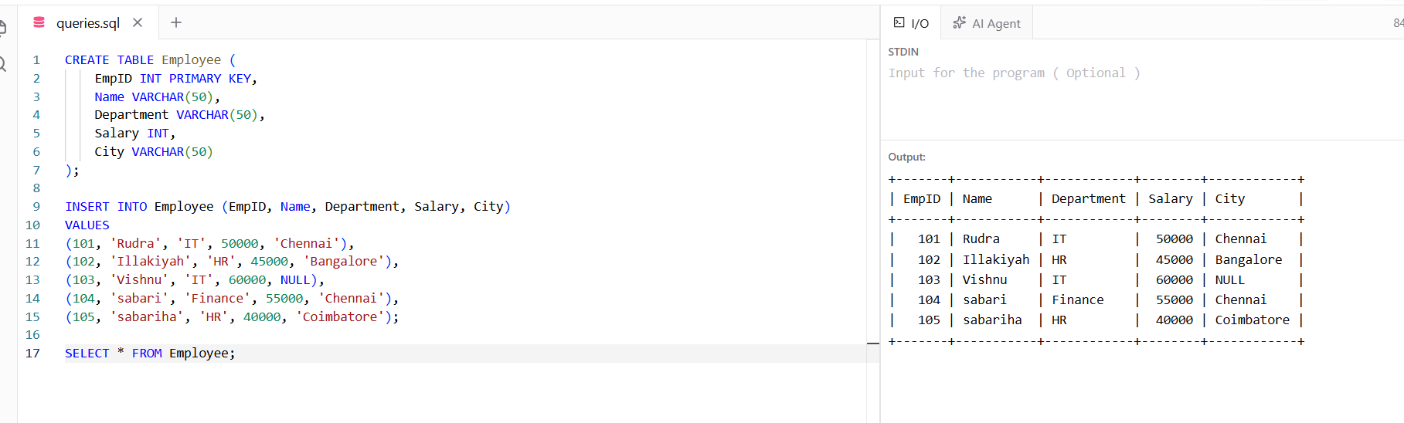

• Display only the Name and Salary of employees.
SELECT Name, Salary FROM Employee;
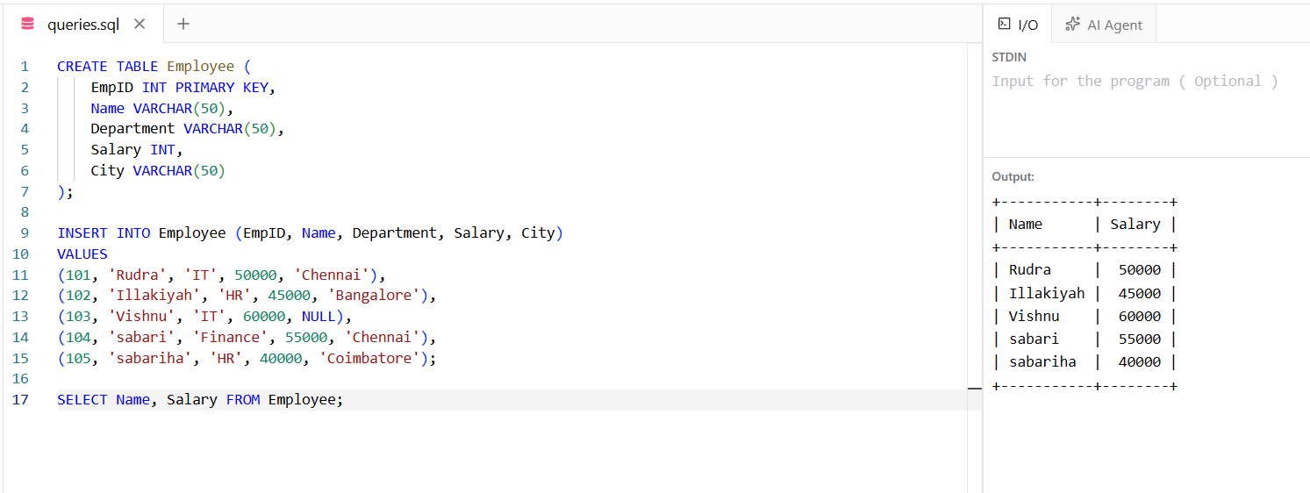

• Display employees whose salary is greater than 50,000.
SELECT * FROM Employee WHERE Salary > 50000; 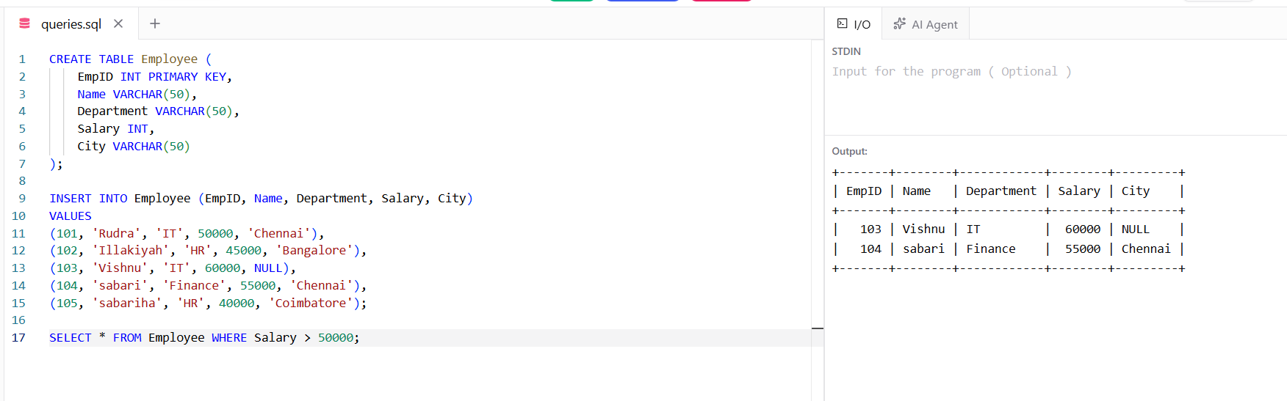

• Display employees who belong to the IT department.
SELECT * FROM Employee WHERE Department = 'IT'; 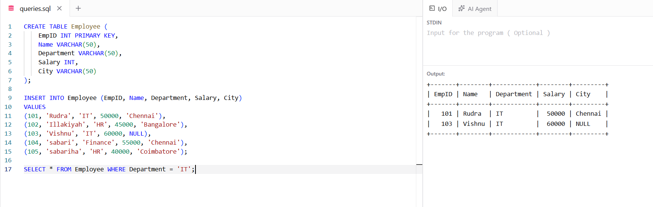

• Display employees whose city is Chennai.
SELECT * FROM Employee WHERE City = 'Chennai';
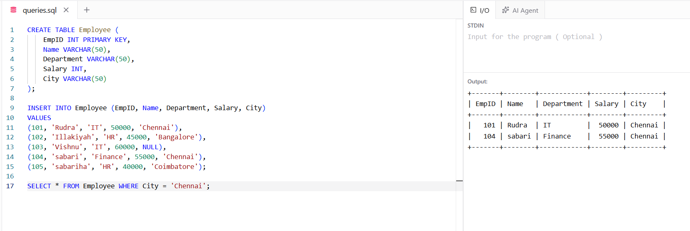

• Display employees whose salary is between 40,000 and 60,000.
SELECT * FROM Employee WHERE Salary BETWEEN 40000 AND 60000;
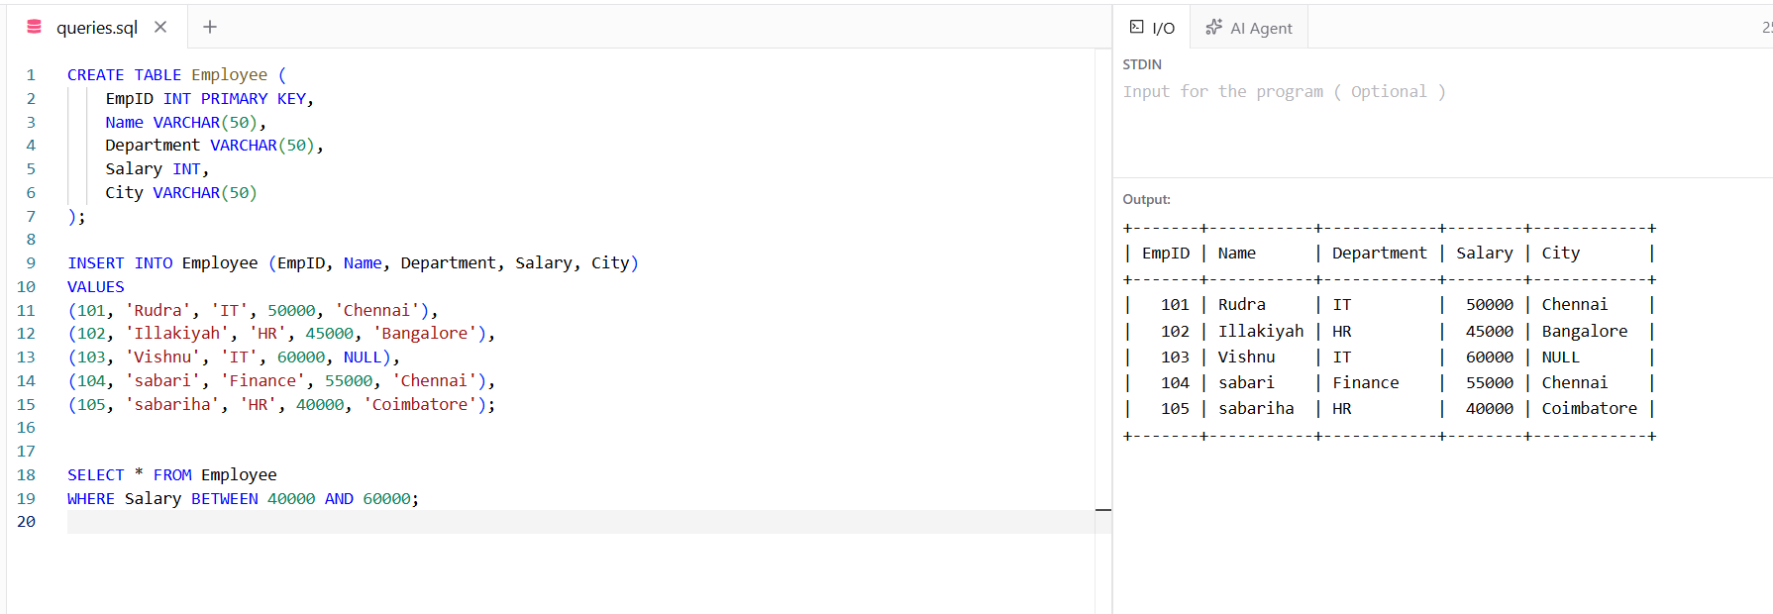

• Display employee names that start with the letter 'A' using the LIKE operator.
SELECT Name FROM Employee WHERE Name LIKE 'A%'; 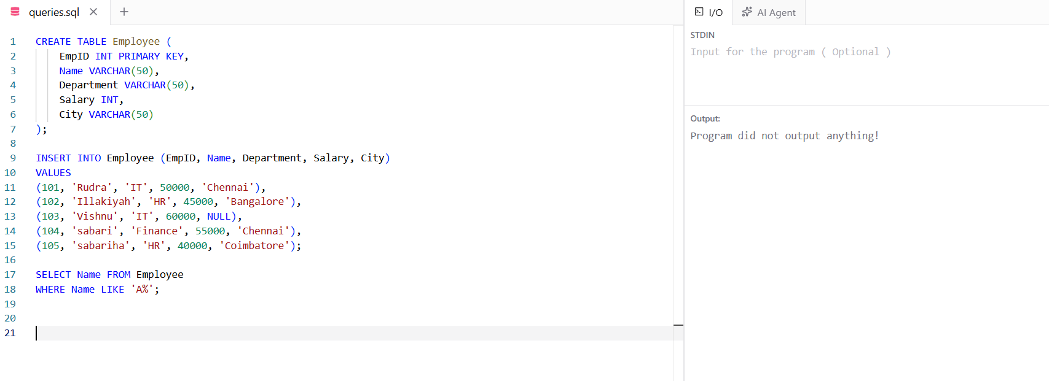

• Display distinct departments from the Employee table.
SELECT DISTINCT Department FROM Employee;
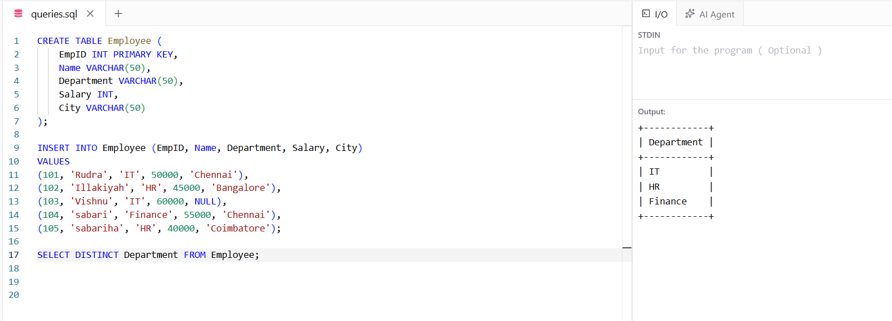

• Display employees whose City value is NULL.
SELECT * FROM Employee WHERE City IS NULL; 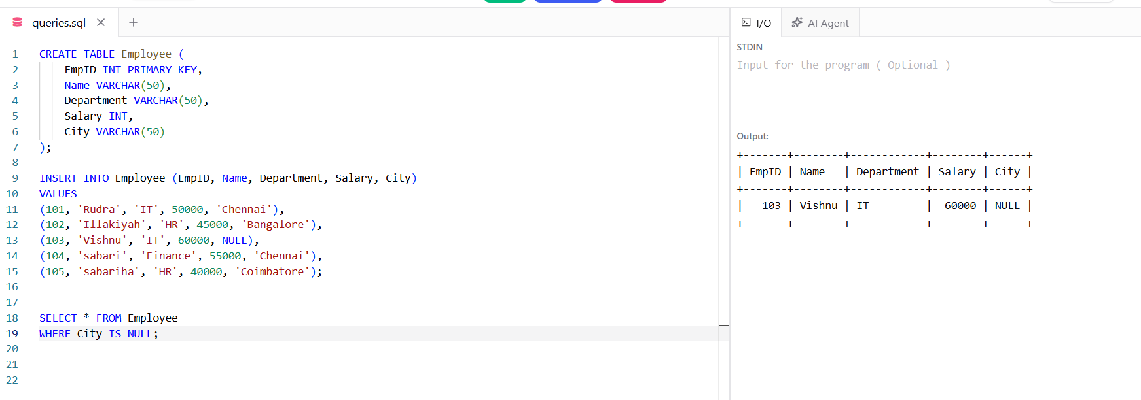

• Find the total salary paid to all employees.
SELECT SUM(Salary) AS Total_Salary FROM Employee; 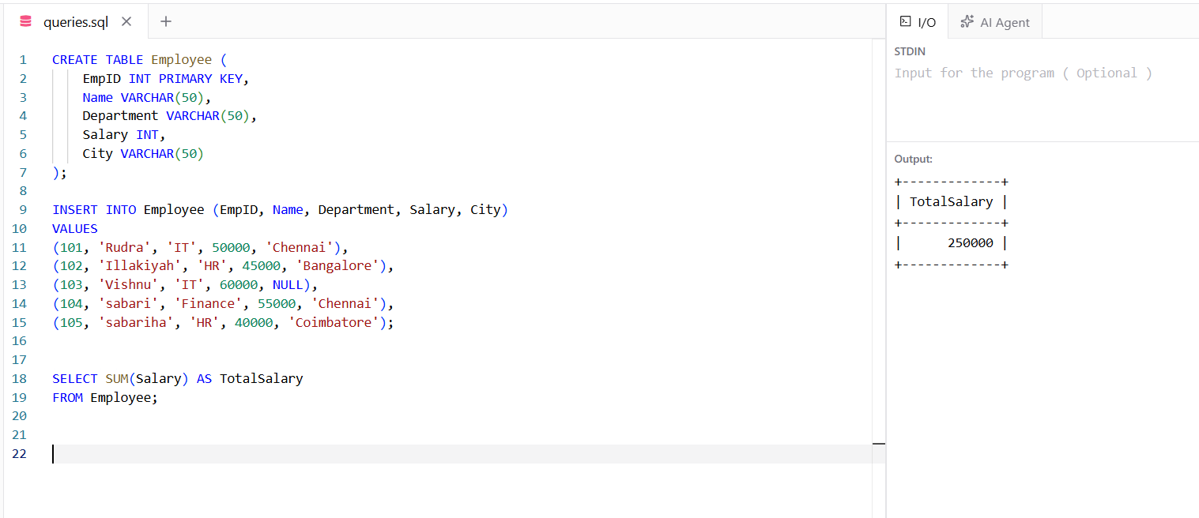

• Find the average salary of employees in the IT department.
SELECT AVG(Salary) AS Average_Salary FROM Employee WHERE Department = 'IT'; 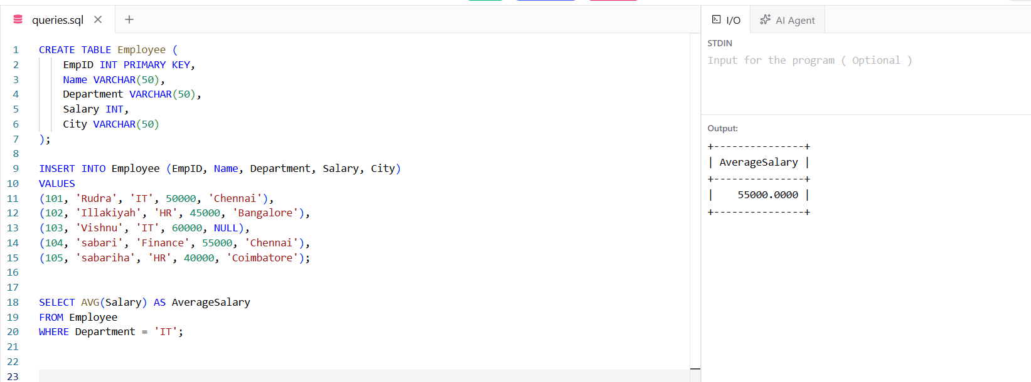

• Count the number of employees in each department using GROUP BY.
SELECT Department, COUNT(*) AS Employee_Count FROM Employee GROUP BY Department; 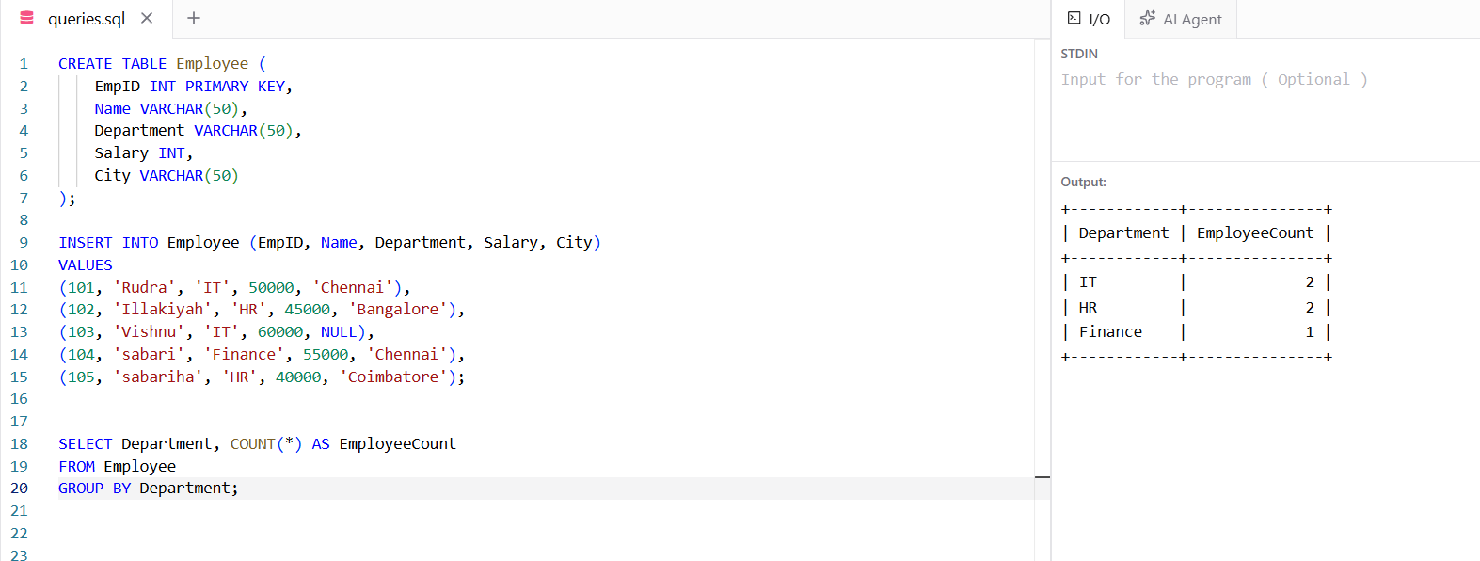

• Display employees whose salary is greater than the average salary (nested subquery).
SELECT * FROM Employee WHERE Salary > (SELECT AVG(Salary) FROM Employee); 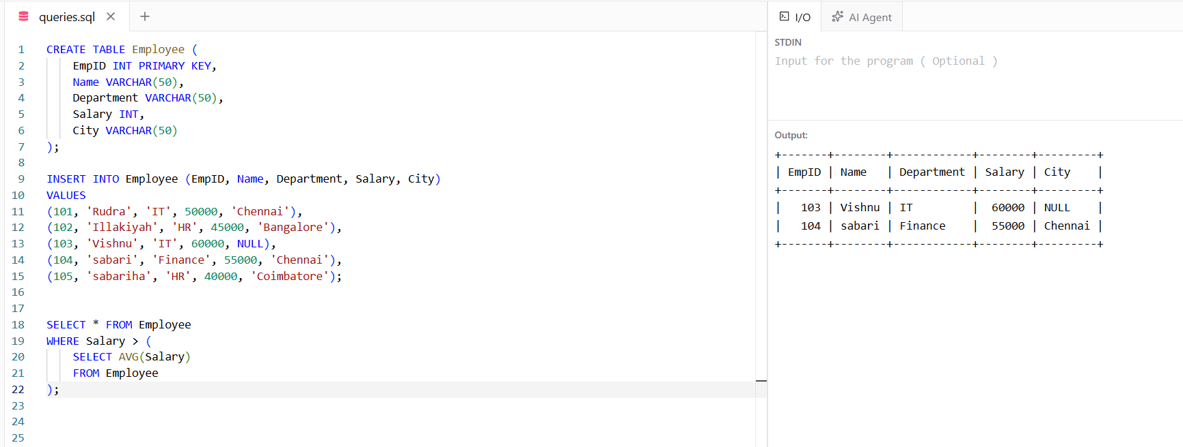

• Write an SQL statement to insert a new employee record.
INSERT INTO Employee (EmpID, Name, Department, Salary, City) VALUES (106, 'PRIYA', 'IT', 52000, 'SALEM');
SELECT*FROM Employee;
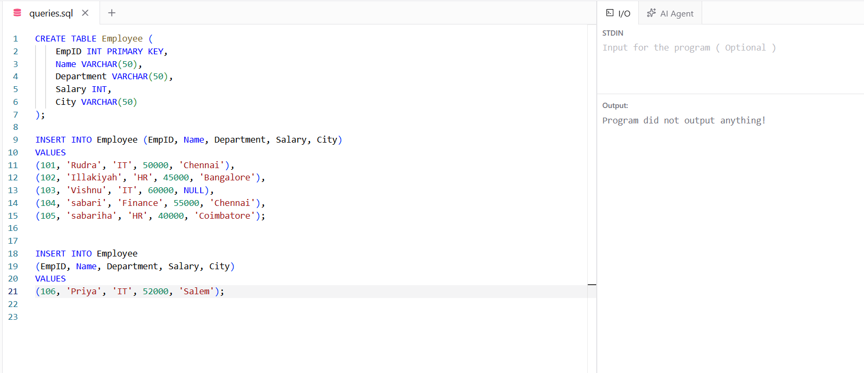

• Write an SQL query to update the salary of employee with EmpID = 105 to 48000.
UPDATE Employee SET Salary = 48000 WHERE EmpID = 105; 

